Perspective Buildings

A study of value, 1 and 2 pt. perspective, and space

**Project Long Term Learning Target**: I can accurately use 1 and 2  
point perspective and value to make an architectural design   
inspired by M.C. Escher.

**Instruction:**   
1.) Practice creating simple **forms** in **1 and   
 2 point perspective.**2.) **Complete packet** working your way through   
 more challenging forms  
3.) Practice **stairs in 1 and 2 point perspective**  
4.) Learn about **MC Escher** and his lithograph,  
 ***Ascending and Decending***  
5.) Draw the **1st draft** your own unique structure  
 **using the criteria below**  
6.) Use **feedback** to **draw final draft**  
7.) Practice creating **value using shading**  
8.) **Shade** in final draft

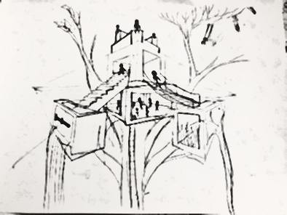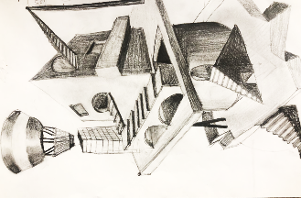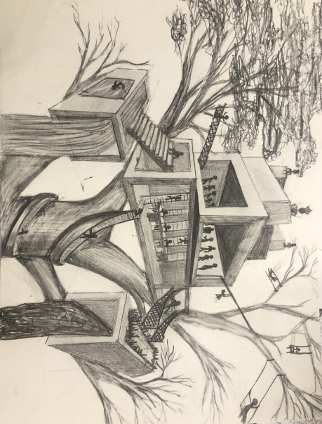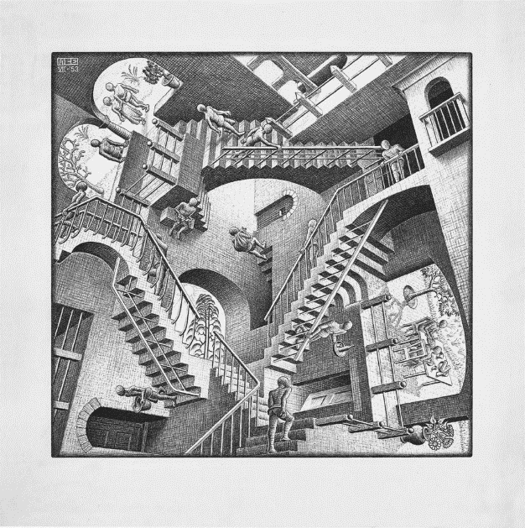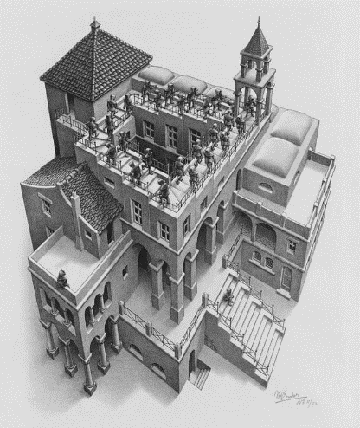

**Graded Criteria**

* Accurate use of value * 1-point perspective used 3 times  
* 3 openings within structure * 1 set of stairs  
* 3 sections of structure. (tall or wide) * Main structure in 2 pt. perspective  
* Craftsmanship and Quality * Uniqueness of structure  
* Integration of human shapes