Graphic Designs

A study of line, emphasis, color, pattern, and space

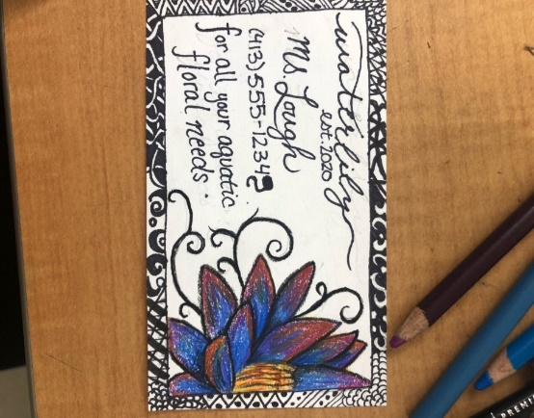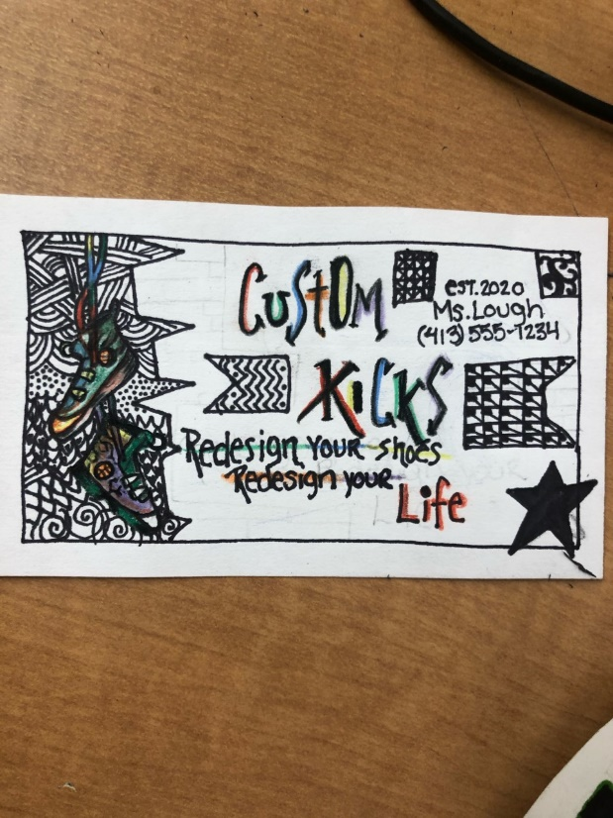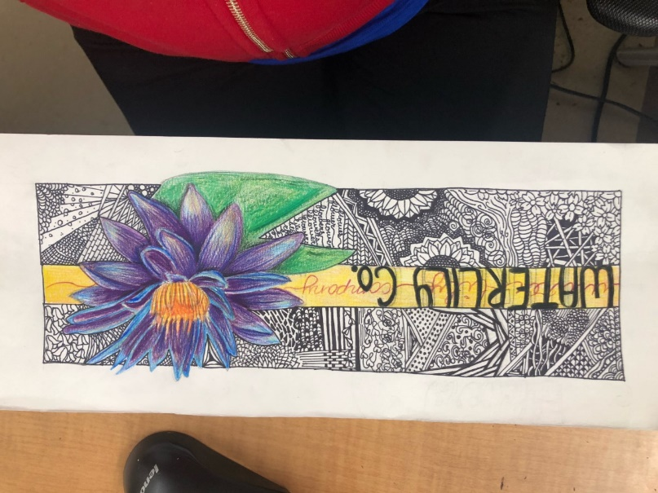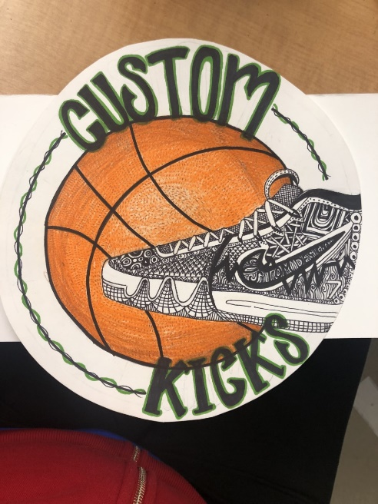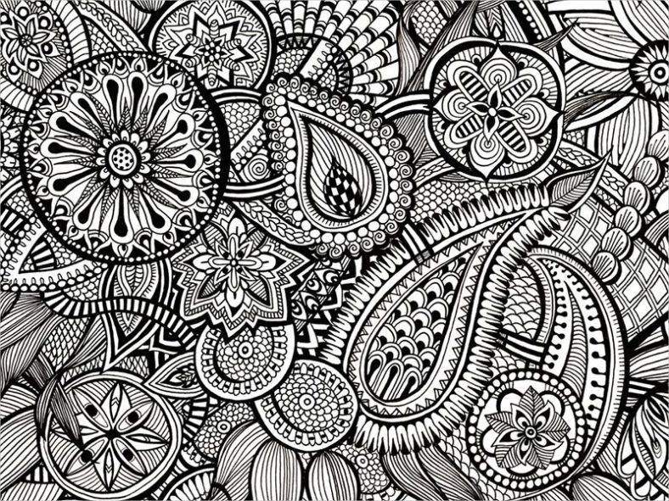

**Project Long Term Learning Target**: I can use my *observational drawing* skills and utilize the art elements and principles **space, line, color, emphasis** and **pattern** to create a **marketable** design.

**Instructions:**

1. Choose and object that you want to design a logo for. (flower, candy, or shoe)
2. Draw draft 1: focus on realism of your object
   1. Get feedback
3. Draw draft 2: focus on compositional choices
   1. Paper layout
   2. Name of company placement
   3. Placement of object
   4. Get feedback
4. Draw draft 3: focus on breaking borders
   1. Break the border at least 3 times
   2. Get feedback
5. Draw final draft of object using the criteria and feedback acquired throughout your drafts
6. Practice creating 10 zentangle designs
   1. Use the 6 different types of lines
7. Draw minimum of 10 zentangle designs in positive or negative space
8. Read the article Color Emotion Guide
9. Color using the psychology of color and how it relates to marketing and graphic design
10. Create a business card for your brand on a blank index card. (this will be used as a name card to display artwork) Include your name, your company name, a fake phone number, a mini drawing of your object, a small amount of zentangle designs, and a slogan for your company.

**Graded Criteria**

* 10 zentangle designs using all 6 types of lines
* Appropriate use of color
* Realistic drawing of object
* Border broken 3 times
* Name of company drawn
* Business card design
* Craftsmanship and Quality